**Geomagnetism Tutorial #2:**

**Spherical Harmonics and Magnetic Field Models**

The Earth’s magnetic field can be compactly and efficiently represented by the weighting of spherical harmonics by Gauss coefficients. They also provide a physically meaningful manner in which to upward and downward continue the geomagnetic field from the source (e.g. at the core-mantle boundary) to large distances (or infinity, in theory).

In this tutorial we will examine the behaviour of spherical harmonics, using them to construct the basis functions and to examine how these can be summed to create maps of the Earth’s magnetic field using the values from the International Geomagnetic Reference Field (IGRF), an internationally agree scientific model of the Earth’s main field. The latest version, IGRF-13, was released in December 2019.

**To start:** The tutorials have been written in Python as Jupyter Notebooks, interactive Python worksheets that you can use to complete the tutorial exercises.

The easiest way to run these is via Binder, just follow this link,

<https://mybinder.org/v2/gh/wb-bgs/EdUniGeomagTutorials/master>

and the materials will load in a virtual environment in your internet browser. The first time you open a notebook, it will take a couple of minutes to setup the environment, subsequent uses will load much more quickly.

Navigate to *notebooks* and select one of the *.ipynb* files (for **i**nteractive **Py**thon **N**ote**b**ook).

Alternatively, if you are familiar with installing Python and want to get more hands on, you can find the materials [hosted here](https://github.com/wb-bgs/EdUniGeomagTutorials), along with some basic instructions on how to set up your own or a university machine.

In a Jupyter notebook, each cell of code (denoted by “In [ ]:” ) can be run by selecting it and pressing “<Ctrl/Cmd>+Enter” or clicking the “Run” button at the top of the page.

Cells can be edited and run in any order, the executed commands are held in memory. Remember if you run cells out of order, they might still depend on variables that are set in previous cells. The notebooks contain instructions indicating which parts to edit for each task. To restart the notebook from scratch and clear all variables, select “Kernal->Restart & Clear Output” from the top menu.

Open the *Spherical-Harmonic-Models-1.ipynb* notebook. Run the first cell (Section 0) to load in the dependencies (the *pandas* and *matplotlib* modules). Read the instructions, and complete the exercises in Sections 1, 2 and 3 to plot some 1D spherical harmonic basis functions and 2D summations, as described below.

**Exercise 1: 1D Associated Legrendre Polynomials**

Modify the degree and order to examine the variation of the Associated Legrendre Polynomials (Pnm) along a 1D meridional slice of the Earth (the core in grey is shown for visualisation). Try value such as degree (n) = 13, order (m) = 0 and others. Here’s an example for P53 (the red line).

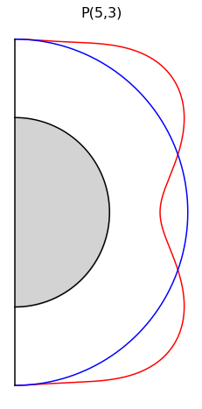

**Exercise 2: Summing together Associated Legrendre Polynomials and spherical harmonics**

By summing together the Associated Legendre Polynomial basis functions (functions of colatitude) with the spherical harmonic basis terms (functions of longitude) that are weighted by the Gauss coefficients, we can represent arbitrarily complex spatial patterns of the magnetic field. Recall that the spatial complexity depends on the degree and order. In this exercise, change the values of the numbers in the ghp variable to plot out 2D maps of the field.

This example is for the Z component for ghp = [1,1,0].

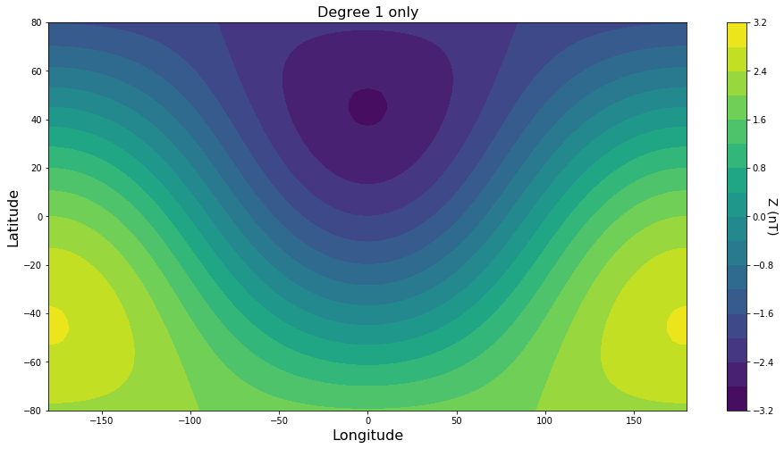

Try out variations of other components and varying the ghp values between -1 and +1 for each coefficient.

**Exercise 3: Compute magnetic field values at a specific location on the surface of the Earth**

Let us compute and check the value of the magnetic field at a specific location on the Earth using the IGRF-13 magnetic field model. Assume that Edinburgh is approximately located at a latitude of 56°N and a longitude of 0°. The IGRF-13 Gauss coefficients for the dipole component of the field at 2020.0 are:

|  |  |
| --- | --- |
| **Gauss coefficient** | **Value (nT)** |
| g10 | -29404.8 |
| g11 | -1450.9 |
| h11 | 4652.5 |

**a.** Use the equations for X, Y and Z components of the magnetic field *at the Earth’s surface* (below) to write down the expressions for the *dipole* field (*l=1)* and then calculate numerical values expected for Edinburgh. Note that *P10=cos θ* and *P11=sin θ*, but that in this case, *θ* is the colatitude, i.e. 90° - latitude. Compute all seven components of the field (X, Y, Z, D, I, H and F). Look in the notes for the relationship between X, Y, Z and D, I, H and F.



**b.** In the Python Notebook, load in the IGRF-13 coefficient file and examine the first 10 rows. Do the 2020.0 coefficients match those in the Table above? Set the colatitude and longitude values for Edinburgh (recall colatitude is 90° -latitude). Set the NMAX = 1, to use only the dipole coefficients.

Run the next cell to compute the X, Y, Z, H, D, I and F values for the field. Do they match your manually computed values? [If not, why not?]

**c.** Go back and set the NMAX = 13, to use the full set of IGRF coefficients. Set the colatitude and longitude values for Edinburgh and compute the component values for the field again. How well do they match the dipole only computation in parts **a** and **b**? Why are the values so different?

**d.** The IGRF-13 model contains a prediction of magnetic field change (secular variation) for five years from 2020.0 to 2025.0. You can compute values of the magnetic field using an online calculator at the BGS Geomagnetism website.

Go to: <https://geomag.bgs.ac.uk/data_service/models_compass/igrf_calc.html>

Compute the values of the field at Edinburgh for 2020.0.

Geodetic coordinates can be entered and you should set the altitude to *0 km above MSL* (on the Earth’s ellipsoidal surface, *MSL* is Mean Sea Level) to give comparable results to your Python ones.

Compare these to the results from part **c.** There are slight differences due to the rounding and the method of computing the matrices and the Legrendre Polynomials in the online FORTRAN code.

**Exercise 4: Compute magnetic field maps for the surface of the Earth**

Finally, create some maps of the IGRF-13 magnetic field across the surface of the Earth. Change the component from ‘Z’ to ‘D’ or ‘I’ or ‘F’ to see the spatial variation.

* You can alter the date from 2020.0 to look at the field back to 1900.0. What areas have changed most?
* You can also alter the altitude – what is the field strength at geostationary orbit (~35,000 km) or at the Moon (~350,000 km)?

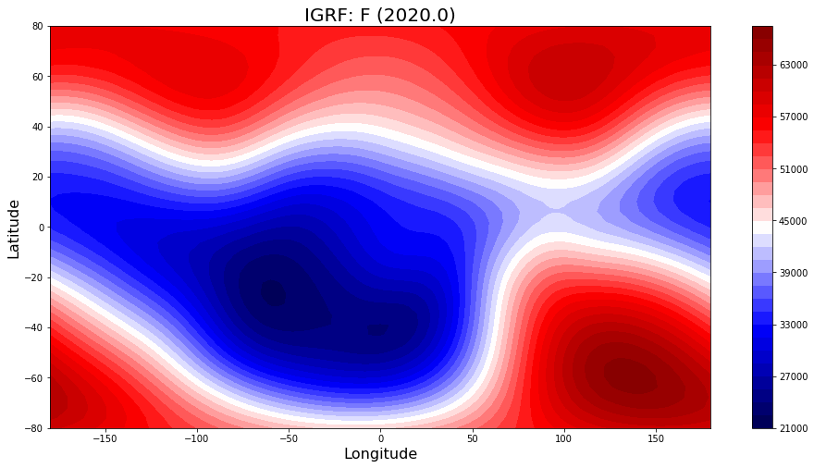

**Additional exercises**

How reliable are spherical harmonics at recovering features of the magnetic field? In the *Spherical-Harmonic-Models-2.ipynb* notebook you can load in a simple land-sea map of the Earth, then sample and invert for the spherical harmonic representation. By altering the degree resolution you can see how the model reconstructs the land and sea map. Note also that it produces artefacts over the sea where there is no land. Finally, what happens if there is a data gap or missing regions from your model – in this case we’ve removed Brazil but for magnetic satellite missions this occurs in the polar gap region (because magnetic satellites generally fly in near-polar orbits, slightly inclined with respect to the Earth’s rotation axis).